MOROGORO REGIONAL REFERRAL HOSPITAL BOARD MEMBERS
FROM 2022 TO 2024

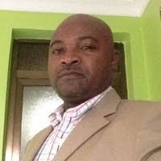
CHAIRPERSON OF THE BOARD
Blasius Lupenza is a Director of Human Resources Alliance One Tobacco Tanzania Ltd, with 10+ years of experience managing and coordinating human resource functions while facilitating the planning and execution of policies and procedures.
Skilled in all aspects of human resource management, including talent recruitment, training and development, payroll administration, employee relations, and conflict resolution. Mr.Blasius has Masters in Bussiness Administration from Mzumbe University and he has experience working with Private and Public institutes.

BOARD SECRETARY
Daniel Joseph Nkungu is a Medical officer in charge of Morogoro Regional Referral Hospital(MRRH). Before Joining MRRH he was a Medical officer in charge at Mwananyamala Hospital where he demonstrated outstanding leadership skills and strengthened health services at the hospital. He is a healthcare practitioner, with a master’s degree in Obstetric & Gynaecology He is a registered member of the Medical Association of Tanzania (MAT), and a member of the Medical Council of Tanganyika (MCT).

BOARD MEMBER
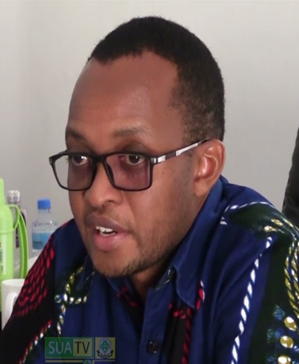
Kusirye Boniface Ukio the Morogoro Regional Medical Officer (RMO), is the epitome of resilience in leadership and public health. From working in the hard-to-reach areas of the country to occupying different positions in health service (DMO Meru, DMO Lindi district, DMO Simanjiro).
Dr Ukio, recounts his story as a leader and medical doctor who, for over a decade, has seen the highs and lows of the country’s health system—its progress and setbacks. He was awarded a Mkapa fellowship upon successful application among hundreds of applications and was posted to work in Simanjiro District, Manyara; a region where healthcare resources were limited in every sense of the word. He has contributed to health service knowledge by publishing studies that impact understanding of different health topics.

BOARD MEMBER
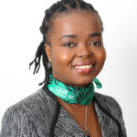
Rose Metta is an economist with over 20 years of experience in the planning, budget and investment areas. She has worked with the National Social Security Fund (NSSF) through its transition from a Provident to a Pension Fund and worked in the Investment, Planning and Budget Directorates. In the cause of her career, she moved to the LAPF Pensions Fund in the capacity of a Compliance Manager which involved supervision of the collection of contributions, registration of members and data record management. She was later moved to the Directorate of Planning and Investments as the Director where her duties involve preparation, monitoring and evaluation of the Fund’s Strategic Plans, Annual Plans and Budgets, Investment Plans and analysis of new investment proposals, monitoring of the Investment portfolio performance. She is a member of the Economic Society of Tanzania and a Diploma holder of "Company Direction" from the Institute of Directors (IOD), UK, an institute dealing with the building of Corporate Governance capacity of Board members worldwide. Ms R. Metta is currently serving in three Boards: - CRDB Bank Plc (one of the largest banks in Tanzania), Mwanza City Council Commercial Company LTD and Msamvu Properties Ltd.

BOARD MEMBER

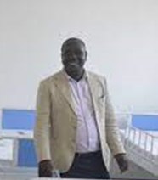
Charles R. Mkombachepa has Ten years’ leadership skills in the health sector where he has been a go-to person being in charge of different district health services. Dr Chalres is a Morogoro Municipal Medical Officer in In-charge, before his appointment, Dr Charles was a District medical officer at MBOZI DC, also he was a District medical officer at Kigamboni DC. With experience in ………, with a special interest in …….... In addition to his surgical practice, he is on the board for MOROGORO regional Referral Hospital where he is going to share technic and use his experience in the health sector he will be a resourceful member of the board.

BOARD MEMBER
Dr. Lusako Mwakiluma founder of Live Your Message, where she turns entrepreneurs into Online Superheroes, and the creator of Wezesha Mabadiliko here she helps people to discover the business they're meant to build, not just the business they can build. She’s the “go-to” brand builder for women and youth empowerment.
Dr Lusako helps entrepreneurs create a business that is authentic and aligned with who they are, to empower them to turn up the dial on their “inner superhero”, so they can be the superhero to their tribe, as well as in their own lives.

BOARD MEMBER
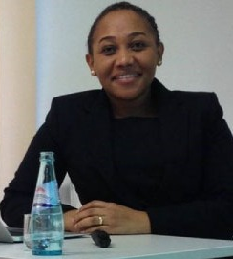
Dr. Hanifa T. Massawe (PhD) is a Lecturer at Mzumbe University and also an Advocate of the High Court of Tanzania. She specializes in commercial laws adding to significant practical legal experience in the subject area. As part of her academic career, Dr. Hanifa engages in teaching, research, consultancies and paper presentations. She teaches different commercial law subjects including contract law, corporate law, tax law, banking and finance law, insurance law e.t.c.
She has also been engaged in different research consultancies at the local government level and some states agencies. These include a study on Willingness to Pay Taxes and Levies at the Mwanza City Council funded by the World Bank, Preparation of a training Manual on Gender Dimensions within the Tanzania Police Force (TPF), participated in the Review of Existing Laws and Proposition of new Legislation in support of the Implementation of the National ID Programme (“Project”) Legal Framework for the National Identification Authority (NIDA).
Dr. Hanifa Massawe has also worked with a number of Local Government councils and state agencies in different consultancy trainings on specific legal aspects and researches. These include training for Tanzania Police Force Senior Assistant Commissioners of Police (SACP’s), training to specific officers within Same District Council, Mwanga District Council, Mvomero District Council, Mpwapwa District Council, Kinondoni Municipal Council, Morogoro Municipal Council, Bahi District Council, Moshi District Council and Temeke Municipal Council. Her specific research interests include corporate governance and compliance, commercial litigation, natural resources law (mining, oil & gas, environmental law), and tax laws.

BOARD MEMBER

DR, Haruna Machibya, is a retired medical doctor, who has quality impressive experience in health services. Dr Machibya held different position in the health sector, as Regional Medical Officer in Mbeya and Lindi Region, District medical officer and an advisor for the ministry of health in different aspects with relation to the on-ground experience.
Dr Machiby is now a Lions Club member an organisation which support different initiatives in community development and health.

BOARD MEMBER
Stephan John Sabian is ….,,,,,,,,,,,,,,,,,,,,,,,,,,,,,,,,,,,,,,,,,,,,,………………………………………………………………………………………………………………………………………………………………………………………………………………………………………………………………………………………………………………………………………………………………………………………………………………………………………………..
BOARD MEMBER

Hassali F. Noobbh is a businessman and a chairperson of Forest street where Morogoro Regional Referral Hospital is located. Elder, Hassani is a good citizen who is recognised for his wise decisions and advice to the community he lives in.
Elder, Hassani has a memory of the Morogoro Region since the leadership of the first Tanzania president. Hayati Mwalimu Kambalage Julius Nyerere.

BOARD MEMBER
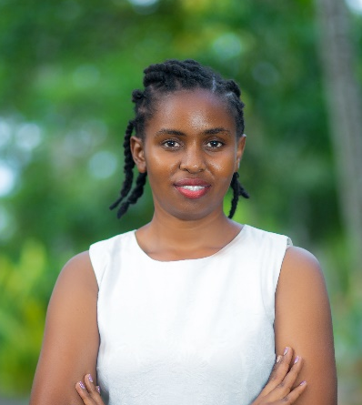
Magdalena Focus work for Sightsavers as programme officer(Gender, advocacy and social inclusion focal person). She holds other roles in the organisation as Advocacy, Gender and Social Inclusion focal person, where she translates learning into simple and doable actions for the organisation, government and other organisations.
She held a master’s degree in International Social Sciences and she has made a name in the advocacy area where she has worked with the organisation to develop, ratify, design and review different policies. She has experience in development sectors where she has worked with Oxfam in gender, extractive industry projects, value chain, National advocacy and livelihood projects. She has also worked in the private sector as assistant director for Hydro Africa International mining company where she obtained conflict resolution leadership skills

